**A**

**PROJECT REPORT**

ON

**COMMERCIAL VEHICLE AUCTION**

Submitted in partial fulfillment for the award of

**Post Graduate Diploma in Advance Computing**

**(PG-DAC) from**

**INSTITUTE OF EMERGING TECHNOLOGIES**

**Authorized Training Centre**



**Under the Guidance of**

**Name of the Guide**

**BY**

**(240845920091)**

**(240845920017)**

**(240845920046)**

**(240845920053)**

**(240845920073)**



**CERTIFICATE**

This is to certify that the project report entitled **COMMERCIAL VEHICLE AUCTION** is a bonfire work carried out by ………andsubmitted in partial fulfilment ofthe requirement for the C-DAC ACTS, DAC course in Institute of Emerging Technology in the batch of Aug 2019.

**Course Coordinator** **External Examiner**

**ACKNOWLEDGEMENT**

This project **COMMERCIAL VEHICLE AUCTION** was a great learning experience for us and we are submitting this work to Advanced Computing Training School (CDAC).

We are very glad to mention the **Name of the Guide** for her valuableguidance to work on this project. Her guidance and support helped us to overcome various obstacles and intricacies during the course of project work.

Our most heart full thanks goes to ***Mr. Sangram Patil*** **(Director ,IET)**who gave all the required support and kind coordination to provide all the necessities like required hardware , internet facility and extra lab hours to complete the project and throughout the course up to the last day here in C-DAC ACTS, Pune.

Sign of student

**Name of Student/s**

**Roll no.**

**Abstract**

The small business sector in the commercial vehicle market often faces challenges such as fraud, lack of secure transactions, and inefficient vehicle selling and buying processes. This **Commercial Vehicle Selling Platform** project aims to address these challenges by developing a robust and secure system tailored to small businesses. The platform ensures secure transactions, helps prevent fraud, and facilitates vehicle auctions, allowing small businesses to list, sell, and buy vehicles efficiently and safely.

The platform provides distinct dashboards for buyers, sellers, and auction hosts, allowing personalized workflows and streamlined vehicle transactions. Small businesses can securely register, list commercial vehicles, and participate in auctions. Buyers can browse and bid on vehicles, while sellers can manage their vehicle listings, interact with buyers, and host or participate in auctions. The system also includes features like secure login, fraud detection measures, vehicle history reports, and messaging between buyers and sellers.

To ensure security and prevent fraud, the platform incorporates advanced fraud detection mechanisms, encrypted data transmission, two-factor authentication, and integration with external APIs to validate vehicle registration and ownership details. Auction functionality will be hosted securely, ensuring transparency and fairness during the bidding process.

The platform also complies with relevant data security regulations to protect sensitive information and ensures that both buyers and sellers are fully protected during transactions. By offering an intuitive and secure interface, the platform aims to create a trustworthy environment for small businesses to buy, sell, and auction commercial vehicles.

This **Software Requirements Specification (SRS)** document outlines the scope, features, technical specifications, and design of the Commercial Vehicle Selling and Auction Platform. It also details the user interface requirements, system workflows, performance benchmarks, and testing protocols to ensure successful project completion. By addressing security issues, facilitating vehicle auctions, and improving transaction efficiency, this platform aims to deliver a user-friendly, secure solution for small businesses in the commercial vehicle market.

**Index**

|  |  |  |
| --- | --- | --- |
| Sr. No. | Title | Page No. |
| 1 | Introduction | 1 |
| 1.1 | Purpose | 2 |
| 1.2 | Scope | 3 |
| 1.3 | Definitions, Acronyms, and Abbreviations | 4 |
| 1.4 | Overview | 5 |
| 2 | Overall Description | 6 |
| 2.1 | Product Perspective | 7 |
| 2.2 | Product Functions | 8 |
| 2.3 | User Classes and Characteristics | 9 |
| 2.4 | Assumptions and Dependencies | 10 |
| 3 | Specific Requirements | 11 |
| 3.1 | Functional Requirements | 12 |
| 3.2 | Non-functional Requirements | 13 |
| 3.3 | Technical Requirements | 14 |
| 4 | External Interface Requirements | 15 |
| 4.1 | User Interfaces | 16 |
| 4.2 | Software Interfaces | 17 |
| 4.3 | Hardware Interfaces | 18 |
| 5 | System Features | 19 |
| 6 | Other Considerations | 20 |
| 6.1 | Constraints | 21 |
| 6.2 | Risks and Mitigations | 22 |
| 7 | UML Diagram | 23 |
| 7.1 | DFD | 24 |
| 7.2 | ERD | 25 |
| 7.3 | Use Case Diagram | 26 |
| 7.4 | Class Diagram | 27 |
| 7.5 | Sequence Diagram | 28 |
| 7.6 | Activity Diagram | 29 |
| 7.7 | Deployment Diagram | 30 |
| 7.8 | System Architecture | 31 |
| 8 | Test Cases | 32 |
| 9 | Screenshots | 33 |
| 10 | References | 34 |

# Commercial Vehicle Auction

1. **Introduction**

In the fast-paced and competitive world of small businesses, having reliable commercial vehicles is crucial for success. Whether it’s transporting goods, providing services, or expanding their operational capacity, commercial vehicles form the backbone of many businesses, especially in industries such as logistics, transportation, construction, and delivery services. However, purchasing and maintaining commercial vehicles often comes with significant challenges, especially when it comes to finding trustworthy sellers, avoiding scams, and navigating complex paperwork.

Traditional online marketplaces, such as OLX, while convenient, have proven to be unreliable and risky for business owners, leading to fraudulent transactions, hidden costs, and a lack of transparency. Small businesses, in particular, are vulnerable to these issues because they may not have the resources or experience to discern legitimate deals from fraudulent ones.

Our platform was created to address these pain points by providing a **dedicated and secure marketplace specifically for commercial vehicles**. We aim to offer a comprehensive, transparent, and efficient solution for buying and selling commercial vehicles, with a special focus on **auction-based transactions**, verified listings, and enhanced fraud prevention measures. Designed with small businesses in mind, our platform ensures that each vehicle listed for sale meets rigorous standards of quality and documentation, and that every transaction is safeguarded by our secure payment system.

Unlike generic marketplaces, where commercial vehicles are often lost among thousands of unrelated items, our platform’s exclusive focus on commercial vehicles means that buyers and sellers can engage in a specialized, streamlined process that takes into account their unique needs. Additionally, our **auction system** provides a fair and competitive environment where buyers can bid on vehicles in real-time, ensuring they are paying market value rather than inflated prices set by sellers with no regulation.

In summary, our platform is more than just a marketplace; it is a **business-enabler** designed to protect both buyers and sellers in the world of commercial vehicle transactions. With our transparent auction model, strict fraud protection measures, and tailored services, we offer a far superior alternative to platforms like OLX, ensuring that small businesses can thrive without the fear of fraud or uncertainty.

* 1. **Purpose**

The purpose of our online commercial vehicle selling platform is multifaceted, centred around providing small businesses with a **secure, transparent, and efficient marketplace** to buy and sell commercial vehicles. This purpose can be broken down into several key objectives that collectively aim to solve the challenges faced by small businesses, enhance the vehicle purchasing process, and foster an ecosystem of trust and reliability.

#### 1. ****To Create a Safe and Fraud-Free Environment:****

Small businesses often fall victim to fraudulent transactions when buying or selling commercial vehicles on general online platforms like OLX. The lack of verification processes, unclear vehicle histories, and unregulated sellers can lead to significant losses, damaged reputations, and even legal complications. The purpose of our platform is to **protect users from fraud** by implementing a robust verification system for both sellers and buyers. We ensure that each listing is backed by detailed vehicle history reports, independent inspections, and authentication of ownership. Our platform acts as a **guarantor** of the transaction, ensuring that businesses can trust the people they are dealing with and the vehicles they are purchasing.

#### 2. ****To Provide Transparency in Vehicle Transactions:****

In the commercial vehicle marketplace, transparency is crucial for making informed decisions. Unlike generic marketplaces where vehicle listings are often vague and incomplete, our platform is designed to provide **full disclosure** about each vehicle. This includes detailed specifications, maintenance records, accident history, ownership details, and real-time condition assessments from independent inspectors. By offering this level of transparency, our platform empowers **buyers to make informed decisions**, eliminating the risks of hidden defects, hidden costs, or misrepresented vehicles. The goal is to ensure that both parties—buyers and sellers—are fully informed and confident in the transaction.

#### 3. ****To Streamline the Vehicle Buying and Selling Process:****

For small businesses, purchasing commercial vehicles is a time-consuming and complex process that often involves navigating through numerous listings, negotiating prices, and ensuring that the vehicles meet the required specifications. Our platform simplifies this process through a **user-friendly interface** that allows businesses to easily browse, filter, and search for vehicles that meet their needs. Additionally, the **auction system** provides a fast and efficient way for businesses to purchase vehicles at market-driven prices, helping them avoid inflated prices or excessive negotiation. By creating an intuitive and simple platform, we save businesses valuable time and effort in securing the right vehicles.

#### 4. ****To Offer a Competitive and Fair Pricing Model Through Auctions:****

One of the key components of our platform is the **auction system**, which introduces an element of competition and fairness to vehicle pricing. Unlike other platforms where prices are set by the seller and may be inflated or negotiable, our auction system ensures that vehicles are sold based on what buyers are willing to pay, reflecting true market value. **Sellers get the best price** for their vehicles, and **buyers can feel confident** that they are paying a fair price that is determined by real-time demand. The auction environment is designed to be **transparent**, where every bid is visible, and all parties are aware of the current standing of the sale. This dynamic model encourages competitive pricing and provides a level playing field for both buyers and sellers.

#### 5. ****To Empower Small Businesses with Financing and Leasing Options:****

Small businesses often face financial constraints, making it difficult to invest in expensive commercial vehicles upfront. Our platform addresses this by offering access to **vehicle financing and leasing options**. These services enable businesses to acquire vehicles without the burden of a large initial payment. With tailored financing options that suit the specific needs of small business owners, we reduce the barriers to entry, enabling more businesses to access the vehicles they need to grow. This helps businesses focus on expanding their operations instead of being weighed down by financial limitations.

#### 6. ****To Foster a Community of Small Businesses:****

Our platform isn’t just a place to buy and sell commercial vehicles; it’s also a space for **small businesses to connect, collaborate, and share knowledge**. We provide tools and features that allow businesses to engage with each other, exchange advice, and even form partnerships. For instance, businesses can discuss bulk purchases, explore fleet management solutions, or share feedback on their experiences with specific vehicle models. By fostering a sense of community, we aim to create a **supportive ecosystem** that enhances the overall success and growth of small businesses.

#### 8. ****To Create a Comprehensive and Efficient Marketplace:****

We aim to create a **one-stop solution** for all commercial vehicle buying and selling needs. In addition to auctions and secure transactions, our platform will offer:

* **Advanced Search Filters**: Allowing businesses to search by vehicle type, make, model, price range, mileage, and other specific features.
* **Vehicle Trade-In Options**: Enabling businesses to trade in their existing vehicles when purchasing a new one, making it easier to upgrade their fleets.
* **Detailed Vehicle Listings**: Each listing will feature high-quality images, detailed descriptions, and specifications, giving buyers all the information they need upfront.

**1.2 Scope**

The scope of our online commercial vehicle selling platform extends beyond merely providing a marketplace for buying and selling vehicles. It encompasses a wide range of services, tools, and features that are designed to cater to the unique needs of small businesses that rely on commercial vehicles for their operations. Our platform is committed to being a **comprehensive ecosystem** that supports businesses through every stage of their vehicle acquisition, ownership, and management journey.

#### ****1. Types of Vehicles Supported:****

Our platform’s scope is focused specifically on **commercial vehicles**, recognizing that these vehicles serve a unique and diverse range of industries. We cater to small businesses and entrepreneurs involved in industries like logistics, transportation, construction, delivery services, and more. We support a variety of vehicles to address these specific needs:

* **Light-duty Trucks and Vans**: Vehicles suitable for small-scale deliveries and short-distance transportation.
* **Heavy-duty Trucks**: Trucks designed for long-haul transportation, capable of carrying large loads.
* **Utility Vehicles**: Service vehicles, vans, and fleet vehicles used for various business operations such as maintenance, repairs, and servicing.

This broad coverage ensures that businesses of all types, from small delivery companies to large construction firms, can find the right vehicle to meet their needs.

#### ****2. Auction and Bidding System:****

One of the standout features of our platform is the **auction system**. The auction process allows buyers to **bid on vehicles in real-time**, which creates a dynamic and transparent pricing model. The bidding system ensures that vehicles are sold at their **true market value** based on what buyers are willing to pay, not what the seller demands. This system also offers the following functionalities:

* **Real-Time Auctions**: Buyers can see the current price and place bids as the auction progresses.
* **Fair Market Pricing**: The auction format ensures that vehicles are sold for a competitive and fair price.
* **Reserve Prices**: Sellers can set a reserve price (minimum acceptable price) to prevent vehicles from being sold too cheaply.
* **Timed Auctions**: Auctions are time-bound, ensuring quick transactions without prolonged negotiations.

This auction model introduces **market-driven pricing**, benefiting both buyers and sellers. Sellers can potentially achieve higher sale prices due to competition, while buyers can acquire vehicles at a fair price without the pressure of traditional fixed-price negotiations.

#### ****3. Vehicle Verification and Authentication:****

To ensure the trustworthiness of all vehicle listings, we implement a rigorous **vehicle verification process**. This includes:

* **Ownership Verification**: Confirming the authenticity of the vehicle’s ownership history and ensuring that the seller is the rightful owner.
* **Vehicle Inspection Reports**: Providing detailed reports on the condition of the vehicle, including its mileage, service history, accident reports, and other critical details. Independent third-party inspectors will conduct thorough evaluations, which are accessible to buyers before making a decision.
* **Vehicle History**: Buyers will be provided with reports on the vehicle’s **accident history**, **maintenance records**, **previous ownership**, and more, allowing them to make informed decisions and avoid any unpleasant surprises.

This ensures that all vehicles listed on the platform are fully transparent, reducing the risk of fraud and enabling buyers to make well-informed decisions.

#### ****4. Secure Payment and Escrow System:****

Our platform offers a **secure payment system** that ensures both buyers and sellers are protected throughout the transaction process. Key features include:

* **Escrow System**: The funds for each transaction are held in escrow until both parties meet their obligations, including vehicle delivery and ownership transfer. This protects both the buyer and the seller by ensuring that no party is left at a disadvantage.
* **Verified Payment Gateways**: We partner with trusted payment providers to ensure secure and seamless transactions. Buyers and sellers can be confident that their financial data is protected.
* **Dispute Resolution**: In case of any disagreements or disputes, we provide a formal dispute resolution process, allowing both parties to resolve the issue in a fair and structured manner.

This payment security feature creates a **trusted environment** for both buyers and sellers, mitigating any risks associated with online transactions.

#### ****7. Buyer Verification and Ratings:****

The platform’s scope includes strict **user verification** procedures to ensure that all buyers are legitimate and trustworthy. This process includes checking their business credentials, confirming PAN details etc, and validating their identity.

This helps to ensure that the marketplace is filled with **reliable buyers** and encourages good practices across the board.

* 1. **Definitions, Acronyms, and Abbreviations**

#### ****Definitions****

1. **User Dashboard**:  
   A personalized interface for users (buyers) to manage their profile, view vehicle listings, track bids in auctions, and manage vehicle purchase history.
2. **Admin Dashboard**:  
   A management interface for administrators to oversee platform activities, manage user accounts, monitor transactions, and manage vehicle listings and auctions.
3. **Vehicle Listing**:  
   A detailed entry of a vehicle available for sale, containing information like make, model, price, mileage, condition, photos, and other relevant details.
4. **Auction System**:  
   A marketplace feature allowing users to bid on vehicles in real-time, with a timed auction process that enables buyers to compete for vehicles.
5. **User Verification**:  
   The process by which the platform ensures that a Buyer is legitimate, verifies identity , and confirms business credentials to build trust in the marketplace.
6. **Customer Support**:  
   A system for users (buyers and sellers) to report issues, ask questions, and receive help regarding transactions, platform functionality, or vehicle-related concerns.
7. **Payment Gateway**:  
   A secure online platform used to process payments, ensuring that all transactions are conducted safely and in compliance with legal standards.

#### ****Acronyms****

1. **API: Application Programming Interface**  
   A set of protocols and tools for building software applications and enabling the integration of external services with the platform.
2. **DFD: Data Flow Diagram**  
   A graphical representation of data movement within the platform’s system, showcasing how information flows between various components.
3. **ERD: Entity-Relationship Diagram**  
   A visual representation that illustrates the relationships between different data entities, such as users, vehicles, transactions, and bids.
4. **CRM: Customer Relationship Management**  
   A system that helps manage customer interactions, track user activity, and maintain customer profiles to improve relationships with users.
5. **SSL: Secure Sockets Layer**  
   A protocol for encrypting information transmitted over the internet, ensuring secure communication between users, admins, and the platform.
6. **UML: Unified Modeling Language**  
   A standardized modeling language used to visually represent the structure and design of the system.
7. **SEO: Search Engine Optimization**  
   The practice of optimizing the platform’s content and structure to improve its ranking on search engines, driving organic traffic to the site.
8. **RTO: Regional Transport Office**  
   Governmental agency responsible for vehicle registration, road safety, and maintaining legal vehicle ownership records.
9. **NFT: Non-Fungible Token**  
   A type of digital asset or token that represents ownership or rights to a unique item, sometimes used in conjunction with vehicle sales to represent digital ownership.
10. **KYC: Know Your Customer**  
    A process for verifying the identity of platform users (especially buyers) to prevent fraud and ensure security.

**Abbreviations**

1. **DB: Database**  
   A collection of structured data, such as user profiles, vehicle listings, and transactions, that is easily accessible and managed within the system.
2. **UI: User Interface**  
   The visual elements through which users interact with the platform, such as buttons, menus, and forms.
3. **UX: User Experience**  
   The overall experience a user has while interacting with the platform, including ease of use, design, functionality, and responsiveness.
4. **HTTP: HyperText Transfer Protocol**  
   A protocol used for transmitting data over the web, allowing users to request and receive information from the platform’s server.
5. **HTTPS: HyperText Transfer Protocol Secure**  
   An extension of HTTP that adds encryption for secure data transmission over the internet, ensuring safe interactions between users and the platform.
6. **CRUD: Create, Read, Update, Delete**  
   The basic operations that can be performed on data, such as creating a new vehicle listing, viewing details, updating vehicle information, or deleting a listing.
7. **B2B: Business-to-Business**  
   Refers to transactions conducted between businesses, such as dealers selling commercial vehicles to other businesses.
8. **B2C: Business-to-Consumer**  
   Refers to transactions where a business sells goods or services directly to consumers (end-users), such as individuals buying vehicles for personal or small business use.
9. **KYC: Know Your Customer**  
   The process of verifying the identity of users (especially sellers) to ensure compliance with legal requirements and mitigate fraud risks.

### ****1.4 Overview****

The **Commercial Vehicle Selling Platform** is a comprehensive and user-friendly online marketplace designed to connect businesses, small enterprises, and individuals with a reliable source for buying and selling commercial vehicles. In response to the increasing concerns about fraud and lack of transparency in the online vehicle market, this platform provides a secure, transparent, and efficient solution. The platform incorporates an auction system for real-time bidding, ensuring users get the best deals on vehicles while ensuring they are safeguarded against fraudulent activities.

### ****Key Features****

1. **Secure Registration and Login:**
   * Sellers and buyers can securely register and log in with robust authentication mechanisms, including optional two-factor authentication (2FA).
   * User profiles, vehicle listings, and transaction histories are securely managed to ensure trustworthiness and transparency.
2. **Vehicle Listings and Auctions:**
   * Sellers can easily create detailed listings for their commercial vehicles, which include essential information such as vehicle specifications, images, and pricing.
   * A built-in auction system allows buyers to bid on vehicles in real-time, with the highest bidder winning the vehicle at the close of the auction.
3. **Seller and Buyer Verification:**
   * Comprehensive seller verification ensures that only legitimate and registered sellers can list vehicles, reducing the chances of fraud.
   * Buyers are assured of secure transactions and transparent vehicle histories, bolstered by features like vehicle inspection reports and previous ownership verification.
4. **Secure Payment Gateway:**
   * The platform integrates a secure payment system, ensuring that all transactions are processed safely. Buyers can pay via multiple channels such as credit/debit cards, bank transfers, or escrow services.
   * Funds are held in escrow until both the buyer and seller meet the agreed terms, providing a layer of security for both parties.
5. **User Dashboards:**
   * **For Sellers:** A comprehensive dashboard for managing vehicle listings, monitoring bids, and tracking sales.
   * **For Buyers:** An intuitive dashboard to browse vehicles, track bids in auctions, and view past purchases.
6. **Data Security and Privacy:**
   * The platform adheres to industry standards for data security, ensuring that sensitive information (user profiles, vehicle details, and payment information) is securely stored and transmitted.
   * Compliance with GDPR and other data protection regulations ensures users' privacy is maintained at all times.
7. **Real-Time Notifications:**
   * Users (both buyers and sellers) receive real-time notifications regarding bids, auction status, new listings, and upcoming auctions to stay up-to-date on their transactions.

### ****Objectives****

* To provide small businesses and individuals with a secure, transparent, and efficient platform to buy and sell commercial vehicles.
* To create a trusted space for vehicle transactions, eliminating the risks associated with traditional platforms like OLX by implementing robust verification and fraud prevention measures.
* To foster a dynamic and competitive marketplace through the integration of real-time auctions and competitive pricing strategies.
* To ensure the security and privacy of user data and transaction information, making the platform a safe place for both buyers and sellers.

### ****Target Users****

1. **Small Businesses and Dealers:**
   * Sell and auction commercial vehicles to a wide pool of potential buyers.
   * Manage vehicle listings and auction participation with ease through a dedicated seller dashboard.
2. **Individual Buyers:**
   * Browse and bid on commercial vehicles that meet specific needs.
   * Receive vehicle inspection reports, ensuring the quality and condition of the vehicles they bid on.
3. **Administrators:**
   * Monitor user activities and ensure platform security, including verification of sellers and transactions.
   * Oversee the smooth running of auctions and ensure the system is free from fraudulent activities.

### ****Future Potential****

The **Commercial Vehicle Selling Platform** offers significant future potential to expand and innovate further:

* **Integration of AI-Based Pricing Tools:**  
  Future updates may include AI-driven pricing tools to help both buyers and sellers determine the most competitive and fair pricing for commercial vehicles, based on market trends and historical data.
* **Blockchain for Transaction Transparency:**  
  The introduction of blockchain technology can provide immutable, transparent records of transactions, making the entire sales and auction process more secure and trustworthy.
* **Integration of Financing Options:**  
  Future versions of the platform will enable buyers to access financing options, such as vehicle loans and lease options, directly through the platform.
* **Mobile Application:**  
  A mobile app will be developed, allowing users to manage vehicle sales, bids, and purchases on the go, making the platform even more accessible to small business owners.

1. **Overall Description**
   1. The **Commercial Vehicle Selling Platform** is a digital marketplace designed to facilitate the buying, selling, and auctioning of commercial vehicles. The platform aims to provide a secure and transparent environment for small businesses, dealers, and individuals looking to buy and sell commercial vehicles such as trucks, vans, and buses. By addressing the prevalent issues of fraud and lack of trust seen in platforms like OLX, this solution integrates vehicle auctions, secure payment methods, and seller verification. The platform will also feature advanced search functionality, real-time notifications, and secure data handling for a seamless user experienc

2. Key features include secure registration and login, vehicle listing management, a

real-time auction system, secure payment processing, and compliance with data security standards. The platform is built using modern technologies like React, Node.js, and MySQL, ensuring scalability and adaptability for businesses of all sizes, from small dealers to larger commercial vehicle dealerships.

**2.1 Product Perspective**

The **Commercial Vehicle Selling Platform** operates as an independent system designed to be seamlessly integrated with existing systems. It is structured with a three-tier architecture consisting of:

1. **Frontend**: User interface that allows interaction with the platform (React.js).
2. **Backend**: Application logic that handles user requests, vehicle listings, auctions, and transactions (Node.js).
3. **Database**: A relational database (MySQL) to store user, vehicle, transaction, and auction data.

The platform’s key features include vehicle listing management, auction functionality, secure registration, and robust payment gateways. The system will be scalable and can be used by a wide range of users, including small dealerships, independent sellers, and larger vehicle auctions.

**2.2 Product Functions**

The **Commercial Vehicle Selling Platform** includes the following core functionalities:

1. **User Registration and Authentication:**
   * **Seller Registration**: Sellers register with personal and vehicle details and undergo a verification process.
   * **Buyer Registration**: Buyers create an account to view and bid on vehicles. Verification is also required.
   * **Two-Factor Authentication (2FA)**: Added security for both buyers and sellers.
2. **Vehicle Listing Management:**
   * **Seller Dashboard**: Sellers can create, update, and manage their vehicle listings, including specifications, images, and pricing.
   * **Auction Management**: Sellers can list vehicles for auction, define the start/end time, and minimum bid prices.
3. **Auction System:**
   * Real-time bidding functionality where buyers can bid on vehicles.
   * Notifications to users when bids are placed and auctions close.
4. **Payment Processing:**
   * Secure payment gateway integration to ensure smooth transactions between buyers and sellers.
   * Funds held in escrow until both parties confirm the transaction details.
5. **Search and Filter Functionality:**
   * A robust search and filtering system allowing buyers to find vehicles based on parameters like model, year, mileage, price, and location.
6. **Seller and Buyer Verification:**
   * Sellers must undergo verification through external services to reduce fraud.
   * Buyers are authenticated via email and optionally 2FA for enhanced security.
7. **Real-Time Notifications:**
   * Instant notifications on bids, auction status, new vehicle listings, and payment updates.
8. **Admin Panel:**
   * Admins verify seller registrations, monitor auction activities, and handle disputes between buyers and sellers.

**2.3 User Classes and Characteristics**

* **Buyers:**
  + Require an easy-to-navigate platform to browse vehicle listings, participate in auctions, and secure payment options.
  + Expect detailed information about vehicles, including specifications, inspection reports, and previous ownership details.
* **Administrators:**
  + Oversee user registration and verification processes.
  + Ensure the platform’s operations are smooth and dispute-free.
  + Monitor all transactions, auctions, and user activities to ensure compliance with platform policies.

**.4 Assumptions and Dependencies**

1. **External Dependencies:**
   * APIs for validating seller information and sending real-time notifications (e.g., Twilio for SMS and email notifications).
   * Secure payment gateways for transaction processing (e.g., PayPal, Stripe).
   * External services for vehicle history checks and inspections.
2. **Assumptions:**
   * Users will have access to the internet and compatible devices (smartphones, tablets, desktops) to use the platform.
   * Sellers will provide accurate and truthful vehicle information to ensure transparency.
3. **Specific Requirements**

The platform must streamline vehicle transactions, ensure transparency, and enhance the experience for both sellers and buyers. Below are the detailed requirements for the system, categorized into functional, non-functional, and technical aspects:

**3.1 Functional Requirements**

**3.1.1 User Registration & Authentication**

* **Buyer Registration:**
  + Buyers register with personal details and are authenticated via email or phone number.
* **Login:**
  + Both sellers and buyers must log in with credentials and optionally enable two-factor authentication (2FA).
* **Forgot Password:**
  + Users should be able to reset their password using a secure email link.

#### 3.1.2 Vehicle Listing Management (Seller Dashboard)

* **Create Listings:**
  + Sellers can list commercial vehicles with detailed specifications, photos, and pricing.
* **Auction Listings:**
  + Sellers can initiate an auction for a vehicle, set minimum bid prices, and define auction duration.

#### 3.1.3 Auction System

* **Real-Time Bidding:**
  + Buyers can place bids in real-time and track the highest bid during the auction.
* **Auction Notifications:**
  + Buyers and sellers receive notifications on bid status and auction closures.

#### 3.1.4 Payment Processing

* **Secure Transactions:**
  + A secure payment gateway will facilitate payments between buyers and sellers.
  + Funds will be held in escrow and released once the transaction is confirmed by both parties.

#### 3.1.5 Admin Panel

* **Verification & Control:**
  + Admins will verify seller and buyer information, ensure accurate vehicle details, and monitor auction activities.

**3.2 Non-functional Requirements**

#### 3.2.1 Performance Requirements

* **System Response Time:**
  + The platform should respond to user requests (such as searching, bidding, etc.) within 3 seconds.
* **Scalability:**
  + The platform should be able to handle 10,000 concurrent users without performance degradation.

#### 3.2.2 Reliability & Availability

* **Uptime:**
  + The platform should have at least 99.9% uptime to ensure uninterrupted access.
* **Backup & Recovery:**
  + Regular backups and recovery systems must be in place to avoid data loss.

#### 3.2.3 Security Requirements

* **Data Encryption:**
  + All personal, payment, and vehicle data must be encrypted both in transit and at rest.
* **Role-Based Access Control (RBAC):**
  + Administrators, buyers, and sellers must have specific access controls based on their roles.
* **Audit Logging:**
  + User activities, such as login attempts, payment actions, and vehicle listings, must be logged for audit purposes.

**3.3 Technical Requirements**

**3.3.1 System Architecture**

#### 3.3.1 System Architecture

* **Frontend:**
  + React.js for the frontend interface, ensuring responsiveness and interactivity.
* **Backend:**
  + Java with spring boot for the backend to handle auction logic, payment processing, and user management.
* **Database:**
  + MySQL for storing user profiles, vehicle listings, auction details, and transaction histories.
* **APIs:**
  + Integration with external APIs for payment processing (e.g., Stripe, PayPal) and vehicle history checks.

#### 3.3.2 Data Storage & Management

* **Relational Database Design:**
  + Database tables for users, vehicles, transactions, and auctions will maintain relationships using foreign keys.

**3.3.3 Deployment Requirements**

* **Cloud Hosting:**
  + The platform will be hosted on secure cloud services such as AWS, Azure, or Google Cloud for high availability.
* **Automated Deployment:**
  + The deployment process will be automated using CI/CD tools like Jenkins, GitLab CI/CD, or GitHub Actions.

1. **External Interface Requirements**

The **Commercial Vehicle Selling Platform** integrates with various external interfaces, essential for ensuring smooth functionality. These interfaces enable the platform to communicate with external systems, databases, APIs, and other third-party services, allowing for the validation of user credentials, payment processing, and efficient management of auctions and transactions. Below are the detailed **External Interface Requirements** for your project:

**4.1 User Interfaces**

The platform features intuitive, secure, and responsive interfaces designed specifically for **buyers** and **administrators**, ensuring smooth functionality and ease of use across devices.

#### ****Web Interface for Buyers:****

* **Secure Login Page:**
  + **Purpose**: Buyers must securely log in using their credentials (email/username and password).
  + **Features**: Optional two-factor authentication (2FA) for enhanced security.
* **Buyer Dashboard:**
  + **Purpose**: A personalized dashboard to manage their buying activity.
  + **Features**:
    - Overview of current and past purchases, upcoming auctions, and saved vehicle searches.
    - Direct access to **notifications**, such as auction updates, winning bids, and vehicle status changes.
* **Search and Filter Vehicles:**
  + **Purpose**: Buyers can search for commercial vehicles based on various criteria.
  + **Features**:
    - Filters for make, model, year, price, location, and other specific features.
    - **Sort** options to rank vehicles by auction status, price, or other parameters.
* **Auction Participation:**
  + **Purpose**: Buyers can actively engage in auctions.
  + **Features**:
    - View live auctions, place bids in real-time, and monitor bid status.
    - Notifications for outbid alerts, auction reminders, and auction end times.
* **Payment Management:**
  + **Purpose**: Secure payment processing for winning bids or vehicle purchases.
  + **Features**:
    - Option to complete payments for auctions or direct purchases.
    - **Transaction History** showing past payments, outstanding invoices, and receipts.
* **Notifications Section:**
  + **Purpose**: Keep the buyer updated on key activities.
  + **Features**:
    - Alerts for upcoming auctions, bid status updates, new listings that match the buyer’s criteria, and vehicle price changes.

#### ****Web Interface for Administrators:****

* **Admin Dashboard:**
  + **Purpose**: Admins have access to a centralized control panel for managing platform operations.
  + **Features**:
    - Overview of system activity, auction status, user behavior, and platform health.
    - Quick access to manage users, monitor active transactions, and view system alerts.
* **Buyer and Seller Verification:**
  + **Purpose**: Admins ensure that users (both buyers and sellers) meet platform standards.
  + **Features**:
    - Review and verify buyer and seller credentials (such as company registration for sellers or financial records for buyers).
    - Approve or reject new registrations, ensuring that only legitimate users participate on the platform.
* **Account and User Management:**
  + **Purpose**: Admins manage all user accounts, including buyers, sellers, and other admins.
  + **Features**:
    - Activate, deactivate, or suspend user accounts based on platform rules.
    - Resolve user issues, update account details, and monitor user activity for compliance.
* **System Monitoring and Logs:**
  + **Purpose**: Ensure smooth operation and security of the platform.
  + **Features**:
    - Real-time system monitoring tools to check server health, transaction statuses, and active auctions.
    - **Audit logs** and **activity trails** to track user actions, auction results, and platform changes for transparency and security.
* **Reporting and Analytics:**
  + **Purpose**: Admins can access reports on platform performance and user activities.
  + **Features**:
    - Generate reports on auction outcomes, transaction volumes, user activity, and platform usage metrics.

**4.2 Software Interfaces**

**4.2.1 Third-Party APIs**

Several third-party APIs are integrated into the platform to enable essential functionalities, including seller verification, notifications, and payment processing.

1. **Seller Credential Verification API:**
   * **Purpose:** To verify the authenticity and credentials of vehicle sellers (dealers).
   * **Data Provided:** Seller’s business registration number, license details, and other business credentials.
   * **API Endpoint:** An external API that connects to regulatory bodies or vehicle registration authorities to verify seller credentials.
   * **Expected Input:** Seller’s business registration number, contact details, and other verification data.
   * **Expected Output:** Validated seller credentials (approved/rejected), ensuring sellers are licensed to sell vehicles.
2. **Twilio API (for Notifications):**
   * **Purpose:** To send real-time notifications (SMS, email) for auction reminders, bid confirmations, and updates to buyers and sellers.
   * **Data Provided:** Auction details, user information (name, contact number, email), bid status.
   * **API Endpoint:** Twilio SMS API or Email API.
   * **Expected Input:** User contact details, auction data (e.g., start/end times, bid confirmations).
   * **Expected Output:** SMS or email notification sent to the buyer or seller confirming auction participation, bid status, or reminders.
3. **Payment Gateway API (for Secure Transactions):**
   * **Purpose:** To handle secure payment transactions for vehicle purchases, deposit payments for bidding, and premium listings.
   * **Data Provided:** Payment amount, user details, payment method (credit card, PayPal, etc.).
   * **API Endpoint:** Stripe, PayPal, or another third-party payment API.
   * **Expected Input:** Payment details including amount, user identification, and payment method.
   * **Expected Output:** Payment confirmation, transaction receipt, and updates to the user’s account or auction status.

**4.2.2 Database Interfaces**

The portal will interact with a relational database (e.g., MySQL or PostgreSQL) to store and retrieve user data, medical records, appointments, and other critical information.

* **Database Connection**:
  + The backend system will connect to a MySQL/PostgreSQL database to handle data storage and retrieval.
  + The system will use SQL queries for CRUD (Create, Read, Update, Delete) operations on tables such as Doctors, Patients, Appointments, Prescriptions, and Consultations.
* **Expected Input**:
  + SQL queries to insert/update or fetch data based on user actions (e.g., booking an appointment, updating patient records).
* **Expected Output**:
  + Data returned from the database, such as patient information, doctor availability, and appointment schedules.

**4.3. Hardware Interfaces**

The system will not have specific hardware interfaces unless integrated with certain medical devices or wearables. However, for smooth operation, it requires the following basic hardware resources:

* **Server Hardware**:
  + Servers hosting the web application and database should be capable of handling high traffic and concurrent users (e.g., cloud-based virtual servers such as AWS EC2, Google Cloud instances).
* **Client Devices**:
  + Desktops, laptops, tablets, and smartphones should support web browsers for accessing the portal.
  + Standard web browser compatibility is required (Google Chrome, Firefox, Safari, Microsoft Edge).
* **Authentication Devices**:
  + Optionally, two-factor authentication (2FA) could use mobile phones, through SMS or authenticator apps (e.g., Google Authenticator, Twilio, or Authy).

**5. System Features**

1. **User Registration & Authentication:**
   * Secure sign-up for buyers and sellers (dealers).
   * Multi-step authentication process (including optional two-factor authentication).
   * Password recovery functionality for buyers and sellers.
2. **Seller Dashboard:**
   * Personalized dashboard for managing vehicle listings, auctions, and sales.
   * Ability to add, update, or delete vehicle listings, including photos, descriptions, and pricing.
   * Access to auction results and transaction history.
3. **Buyer Dashboard:**
   * Personalized dashboard for managing bids, viewing auction results, and tracking vehicle purchases.
   * Ability to save favorite vehicles, track auction progress, and set reminders for upcoming auctions.
   * View detailed vehicle information, including history reports, specifications, and pricing.
4. **Auction Management:**
   * Real-time auction participation for both buyers and sellers.
   * Bidding system with automatic updates for real-time auction progress.
   * Notifications for auction start, bidding milestones, and auction closing.
   * Sellers can set minimum bid prices and auction durations.
5. **Vehicle Listing Management:**
   * Sellers can list their vehicles for sale, providing detailed specifications, photos, and videos.
   * Ability to manage vehicle availability, pricing, and descriptions.
   * Option for sellers to set vehicle auction start and end times.
6. **Secure Messaging System:**
   * Real-time chat functionality for secure communication between buyers and sellers.
   * All messages are encrypted to ensure privacy between parties during transactions.
7. **Search Functionality:**
   * Buyers can search for vehicles based on parameters like make, model, year, price range, location, and auction status.
   * Sellers can filter and manage their listings by price, status, and vehicle details.
   * Advanced search features for quick and efficient discovery of vehicles on sale or auction.
8. **Notifications System:**
   * Automated email/SMS notifications for auction updates, bid confirmations, and reminders for upcoming auctions.
   * Admins can send system-wide updates, alerts, and promotions to both buyers and sellers.
   * Notifications for the successful sale of vehicles, bidding milestones, and changes in auction status.
9. **Role-Based Access Control (RBAC):**
   * Different access levels for buyers, sellers, and administrators to ensure data security and platform integrity.
   * Admins can manage user roles, monitor auction activities, and review transactions.
   * Sellers can manage their vehicle listings, while buyers have access to bid and track auctions.
10. **Data Security & Compliance:**

* Compliance with relevant data protection laws such as GDPR (for European users) and any financial regulations for transaction processing.
* Encryption of sensitive data both in transit (HTTPS) and at rest.
* Secure management and storage of buyer, seller, and transaction data.

1. **Admin Panel:**

* Admins can manage buyer and seller accounts, verify seller credentials, and monitor auction activities.
* Ability to approve, deactivate, or delete user accounts, manage listings, and resolve disputes.
* Admins can also generate reports on user activity, auctions, and financial transactions.

1. **External API Integration:**

* Integration with third-party services for vehicle history validation (e.g., Carfax), payment processing (e.g., Stripe, PayPal), and SMS notifications (e.g., Twilio).
* APIs for payment gateway integration, facilitating secure online transactions between buyers and sellers.

1. **Mobile-Friendly Interface:**

* Fully responsive and optimized for use on mobile devices, ensuring accessibility on smartphones and tablets.
* The mobile-friendly platform ensures buyers and sellers can manage bids, view listings, and interact with auctions on-the-go.

**6. Other Considerations**

**6.1 Constraints**

1. **Performance**:
   * The system must handle multiple concurrent users without performance degradation.
2. **Scalability**:
   * Designed to accommodate growing user bases and additional features in the future.
3. **Compliance**:
   * Adherence to regulatory standards like GDPR and HIPAA for data security.

**6.2 Risks and Mitigations**

1. **Data Security and Privacy Risks:**
   * **Risk:** Unauthorized access to sensitive user data (e.g., buyer/seller details, transaction history) or data breaches could compromise the privacy of users. Non-compliance with regulations (e.g., GDPR) may also lead to penalties.
   * **Mitigation:** Implement strong encryption for data both in transit (using HTTPS/SSL) and at rest (using AES-256 encryption). Ensure secure authentication methods (e.g., two-factor authentication). Regularly audit security practices and ensure compliance with relevant data protection regulations, including GDPR.
2. **System Downtime and Reliability Issues:**
   * **Risk:** System downtime could lead to disruptions in user access, particularly during high-traffic events like vehicle auctions, affecting user trust and engagement.
   * **Mitigation:** Ensure high system availability by hosting the platform on scalable cloud infrastructure with redundancy and load balancing. Implement regular backups and disaster recovery plans. Target 99.9% uptime and employ monitoring tools to proactively identify and resolve system issues.
3. **Integration with External Systems:**
   * **Risk:** Issues could arise while integrating with third-party services such as payment gateways (e.g., PayPal, Stripe), notification services (e.g., Twilio), or external APIs for vehicle history checks.
   * **Mitigation:** Carefully evaluate third-party providers and ensure they meet performance and security requirements. Establish clear API documentation and implement fallback strategies to handle potential integration failures, including offline modes or manual processing when necessary.
4. **User Adoption and Usability Issues:**
   * **Risk:** Users (both buyers and sellers) may find it difficult to navigate the platform, which could lead to a low adoption rate or user frustration, especially among those with limited technical knowledge.
   * **Mitigation:** Design a simple, intuitive interface for easy navigation. Provide user guides, tutorials, and customer support for both buyers and sellers. Conduct usability testing with real users to gather feedback and make refinements before full launch.
5. **Scalability and Performance:**
   * **Risk:** The platform may struggle to handle high volumes of traffic, particularly during peak times like auctions or high-demand vehicle listings, leading to slow response times or system crashes.
   * **Mitigation:** Use scalable cloud infrastructure that can dynamically adjust to user demand. Implement load balancing, optimize database queries, and introduce caching mechanisms to improve performance during peak periods.
6. **Regulatory Compliance Risks:**
   * **Risk:** Non-compliance with data protection laws and financial regulations, such as GDPR for European users or PCI DSS for payment processing, could lead to legal and financial penalties.
   * **Mitigation:** Design the platform to meet regulatory requirements from the outset. Regularly update the system to reflect changes in legal and financial regulations. Work with legal advisors to ensure continuous compliance, especially with respect to sensitive user data and payment processes.
7. **Technical Debt and Maintenance:**
   * **Risk:** Accumulation of technical debt could hinder future updates, feature additions, or overall platform maintenance, affecting the system's long-term performance and adaptability.
   * **Mitigation:** Follow industry best practices for clean, modular code development. Implement a structured code review process and keep detailed documentation. Plan for regular refactoring to manage technical debt and ensure the system remains adaptable for future improvements.
8. **Seller and Buyer Verification Failures:**
   * **Risk:** Errors or delays in verifying the credentials of sellers and buyers (e.g., identity verification, vehicle ownership history) could lead to fraudulent activity or disputes.
   * **Mitigation:** Use trusted third-party verification services to validate seller and buyer identities. Implement manual backup verification processes if automated verification fails. Monitor flagged accounts for suspicious activities and ensure all users meet platform guidelines before participating in auctions or transactions.

**7 UML Diagram**

**7.1.DFD**

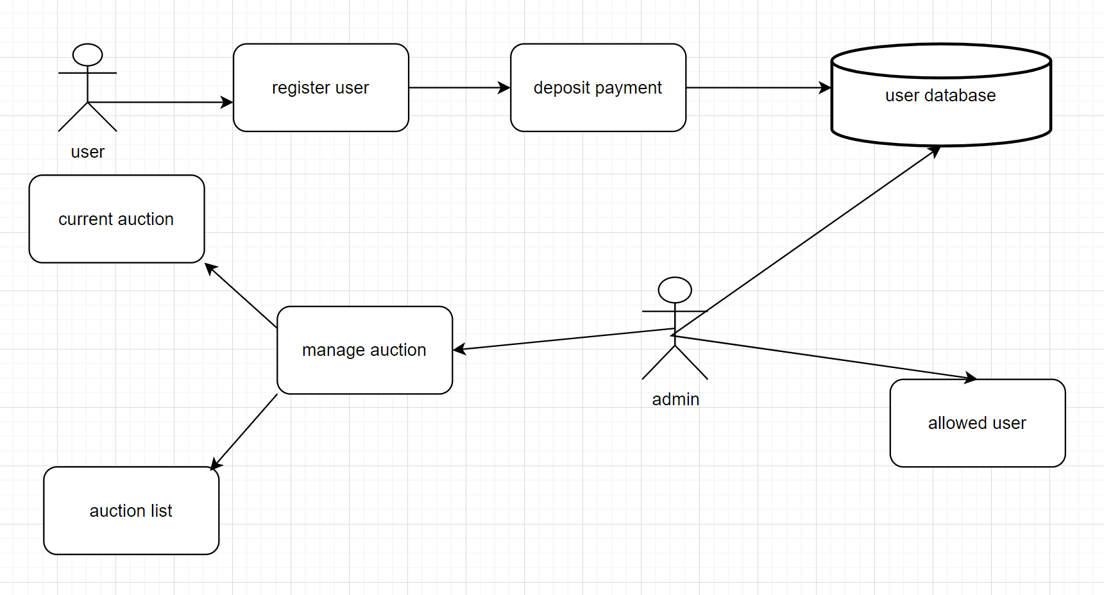

**7.2 ERD**

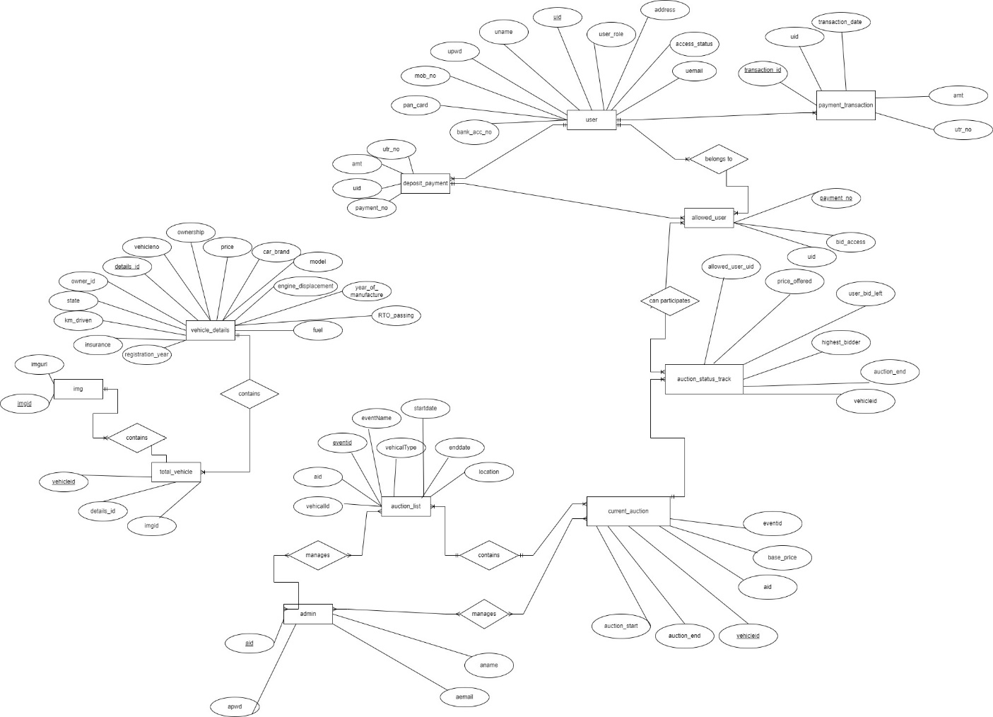

**7.3 Use case diagram**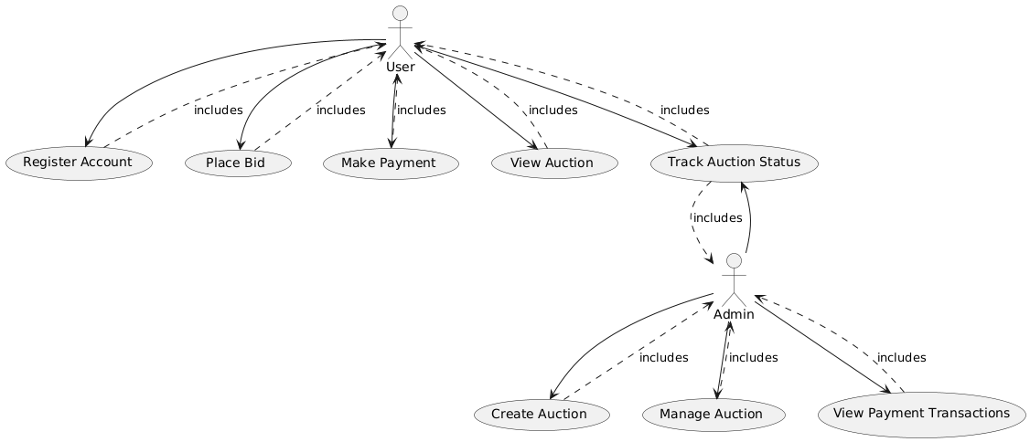

**7.4 Class Diagram**

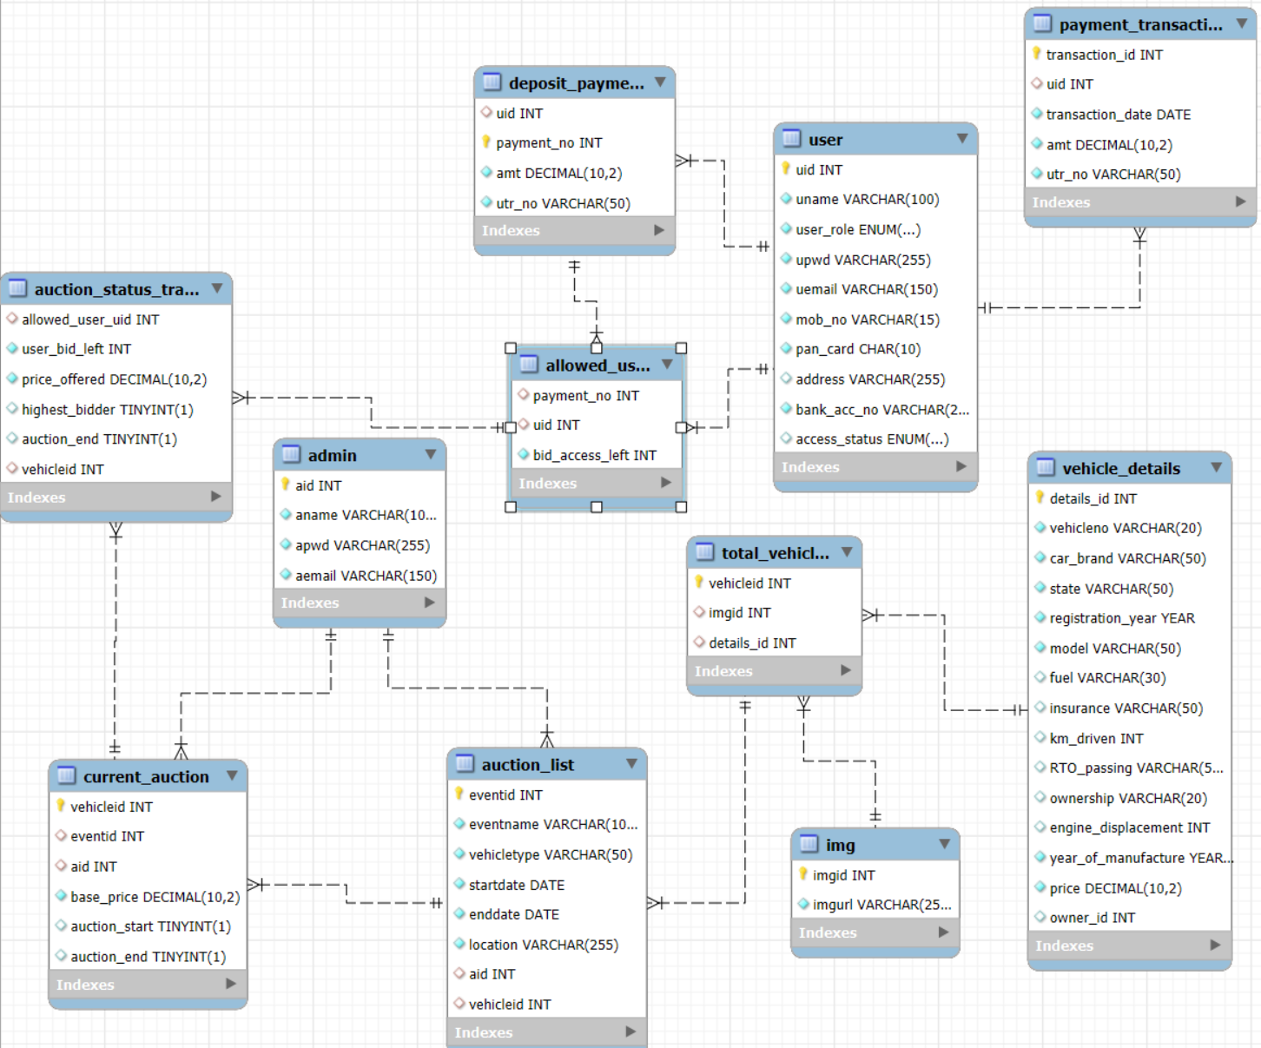

**7.5 Sequence diagram**

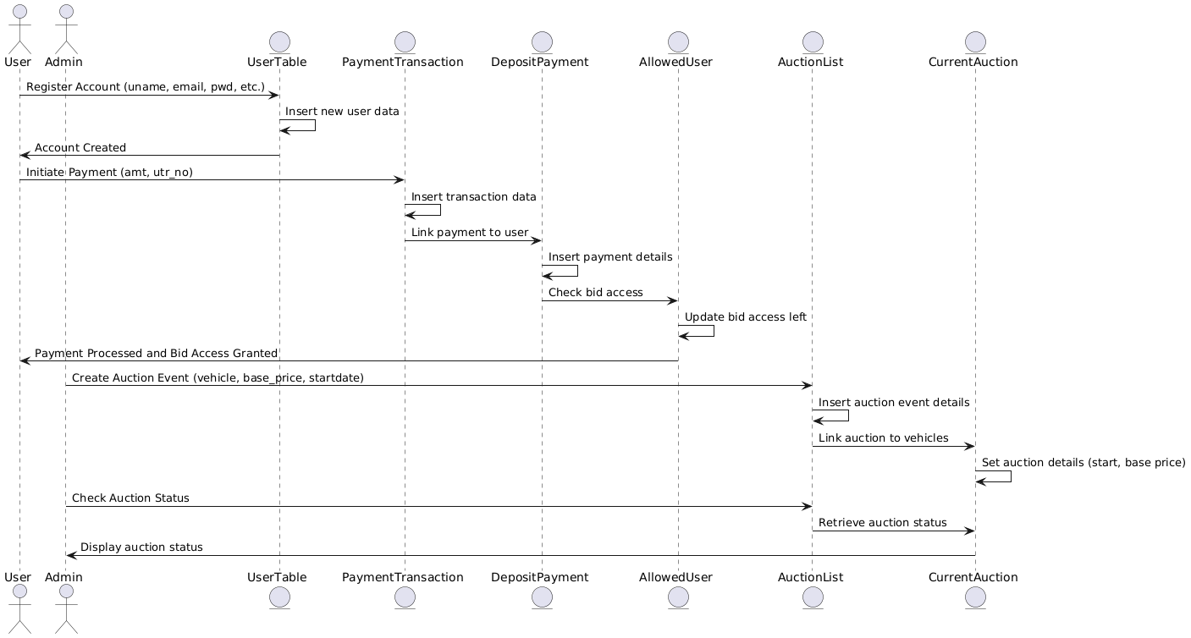

**7.6 Activity Diagram**

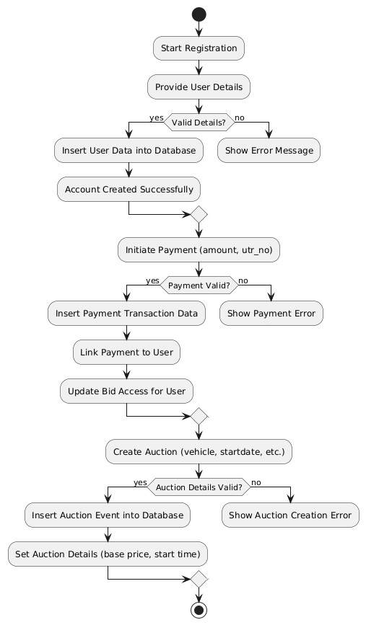

**7.7 Deployment diagram**

**7.8 System Architecture**

**8 Test Cases**

**9 Screenshots**

**10 References**